**CAR SALES REPORT**

**Background**: Our company is a car dealership that sells various car models. To effectively track and analyse our sales performance, we need a comprehensive Car Sales Dashboard in Power BI.

**Objective**: The objective of this project is to design and develop a dynamic and interactive Car Sales Dashboard using Power BI. The dashboard will visualize critical KPIs related to our car sales, helping us understand our sales performance over time and make data-driven decisions. Problem Statement 1: KPI’s Requirement The dashboard should provide real-time insights into key performance indicators (KPIs) related to our sales data. This will enable us to make informed decisions, monitor our progress, and identify trends and opportunities for growth.

1. **Sales Overview:**

• Year-to-Date (YTD) Total Sales

• Year-over-Year (YOY) Growth in Total Sales

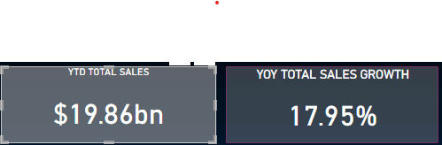

1. **Average Price Analysis:**

• YTD Average Price

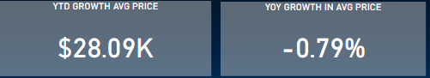• YOY Growth in Average Price

1. **Cars Sold Metrics:**

• YTD Cars Sold

• YOY Growth in Cars Sold

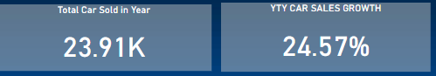

1. 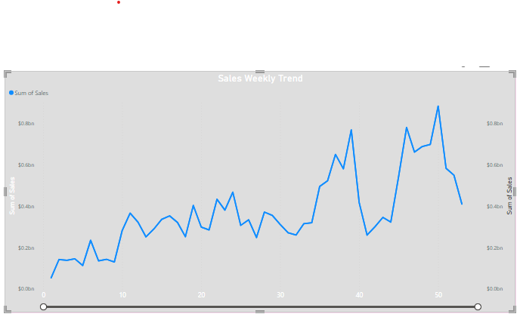**Sales Weekly Trend**: Display a line chart illustrating the weekly trend of sales. The Xaxis should represent weeks, and the Y-axis should show the total sales

1.Sales drastic drop in the month of OCT

2.Month of Dec Sales at maximum levels but not sustain

3.Major fluctuation of sales from sep to dec

Resions : **Economic Uncertainty**: The pandemic caused significant economic uncertainty, leading to job losses, reduced consumer spending, and overall economic downturn. Many people were hesitant to make major purchases like cars during this time.

**Supply Chain Disruptions**: The pandemic disrupted global supply chains, leading to shortages of key automotive components. This shortage affected production capacities and, subsequently, the availability of new vehicles for purchase.

**Reduced Consumer Confidence:** The economic uncertainty, coupled with concerns about the pandemic's duration and impact, led to reduced consumer confidence. Many potential car buyers were hesitant to commit to large purchases amidst such uncertainty.

**Solutions:**

**Online Sales Platforms**: Enhance online sales platforms to facilitate virtual car shopping experiences. This includes detailed vehicle descriptions, high-quality photos, virtual tours, and interactive features that allow customers to explore different models and configurations from the comfort of their homes.

**Digital Marketing**: Invest in targeted digital marketing campaigns to reach potential customers effectively. Utilize social media advertising, search engine optimization (SEO), email marketing, and other digital channels to promote vehicles and special offers.

**Customer Incentives**: Offer incentives and promotions, such as rebates, discounts, and special financing deals, to encourage customers to make a purchase. Consider loyalty programs or referral bonuses to reward existing customers and attract new ones.

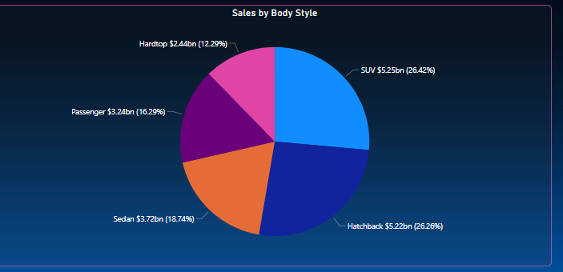**2. Total Sales by Body Style**: Visualize the distribution of total sales across different car body styles using a Pie chart.

**Key Factors For most selling SUV & Hatchback Series:**

**Urbanization and Lifestyle Shifts:** Urbanization and changing lifestyle preferences, such as a desire for smaller, more maneuverable vehicles suitable for city driving, can drive demand for hatchbacks and compact SUVs. Analyzing regional sales data can provide insights into geographic variations in consumer preferences.

**Influence of Marketing and Branding:** Effective marketing campaigns highlighting the features, benefits, and lifestyle associations of SUVs and hatchbacks can influence consumer perceptions and purchasing decisions. Brand reputation and perceived value for money also play significant roles in driving sales.

**Long-Term Resale Value**: Consumer perceptions of SUVs and hatchbacks as retaining their value over time due to factors such as durability, reliability, and demand in the used car market can influence purchasing decisions.

**Need to More Focus on Hardtop Model Consumers:**

**Aesthetics and Design Trends**: Changes in automotive design trends and aesthetics may impact the appeal of hardtop cars. Consumers may prefer the sleek lines and practicality of SUVs and crossovers over the more traditional styling of hardtop coupes and convertibles.

**Safety Concerns**: Consumers prioritize safety features when purchasing vehicles, and some hardtop car models may lag behind in terms of safety technology compared to newer vehicle segments. Consumers may opt for vehicles with the latest safety features, including collision avoidance systems and pedestrian detection, which may not be as prevalent in older hardtop models.

**Technological Advancements**: Advances in automotive technology have made traditional hardtop cars less appealing to some consumers. Features such as autonomous driving capabilities, advanced driver-assistance systems (ADAS), and connectivity options may be more readily available in newer vehicle segments, making hardtop cars seem outdated in comparison.

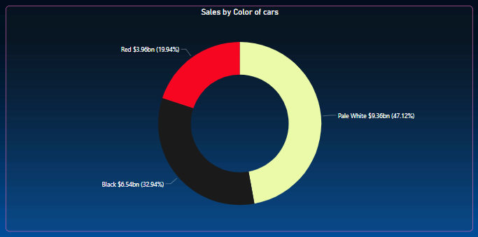**3.Total Sales by Color**: Present the contribution of various car colors to the total sales through a donut chart.

1. 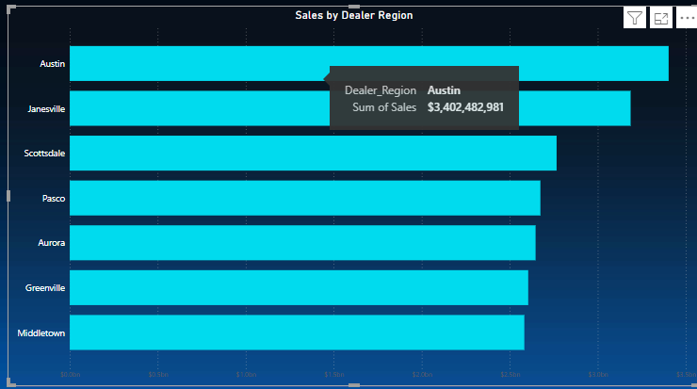**Cars Sold by Dealer Region**: Showcase the sales data based on different dealer regions using a bar chart to visualize the sales distribution geographically.

**Austin & Janesville most car selling Region:**

**Demographic Factors**: Analyzing demographic data, such as age, income levels, and lifestyle preferences, can provide insights into the types of cars being sold in these regions. For example, younger demographics might prefer smaller, fuel-efficient cars, while affluent customers might opt for luxury vehicles.

**Urbanization and Commuting Needs**: Urban areas like Austin might have higher car ownership rates due to commuting needs and limited public transportation options. Similarly, Jensville's population might rely heavily on cars for transportation due to its suburban or rural characteristics.

**Population Growth**: Both Austin and Jensville might be experiencing significant population growth, leading to increased demand for cars. A growing population typically correlates with higher vehicle sales as more people require transportation.

**Economic Prosperity**: These regions might be experiencing economic prosperity, resulting in higher consumer confidence and purchasing power. Strong local economies can stimulate car sales as people feel more comfortable making significant purchases.

1. 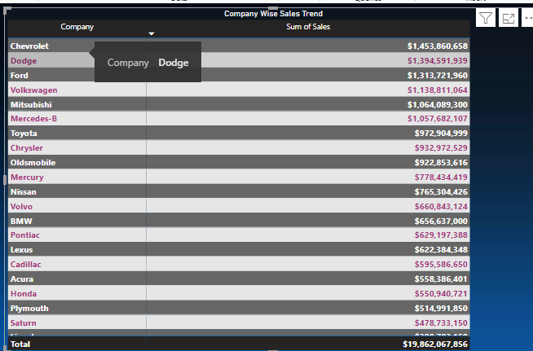**Company-Wise Sales Trend in Grid Form**: Provide a tabular grid that displays the sales trend for each company. The grid should showcase the company name along with their sales figures.

**TOP 5 Most Selling Cars**

Chevrolet

Dodge

Ford

Volkswagen

Mitsubishi

**Bottom 5 Selling Cars**

Jaguar

Infiniti

Saab

Hyundai

Jeep

